Chapter 10, Solution 28.

The frequency-domain version of the circuit is shown below, where

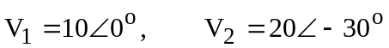 .

1 j4 j4 1

-j0.25
+ +

V₁ I₁ 1 I₂ V₂
- -

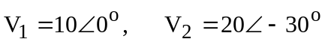

Applying mesh analysis,

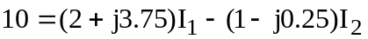 (1)

(2)

From (1) and (2), we obtain

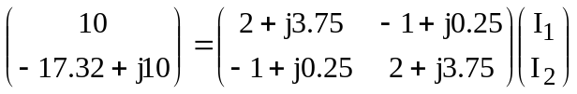

Solving this leads to

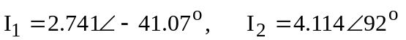
Hence,

i₁(t) = 2.741cos(4t–41.07˚)A, i₂(t) = 4.114cos(4t+92˚)A.

